The below link should take you directly to the A Troop 4/12 Cav information now posted on the Texas Tech Vietnam Archive

http://www.vietnam.ttu.edu/virtualarchive/items.php?ui=N000634

Should the above link not work use the following steps to view the A Troop 4/12 Cav information on the Texas Tech site.

Click on the below link, this should take you to the Home Page of the

http://www.vietnam.ttu.edu/

Texas Tech Vietnam Center and Archive Virtual Vietnam Archive (you see a page similar to the one below). Scroll down to the bottom right hand side and click on Virtual Vietnam Archive link.

You should see a page similar to the one below; scroll down on the left hand side and click on the Search the Virtual Vietnam Archive

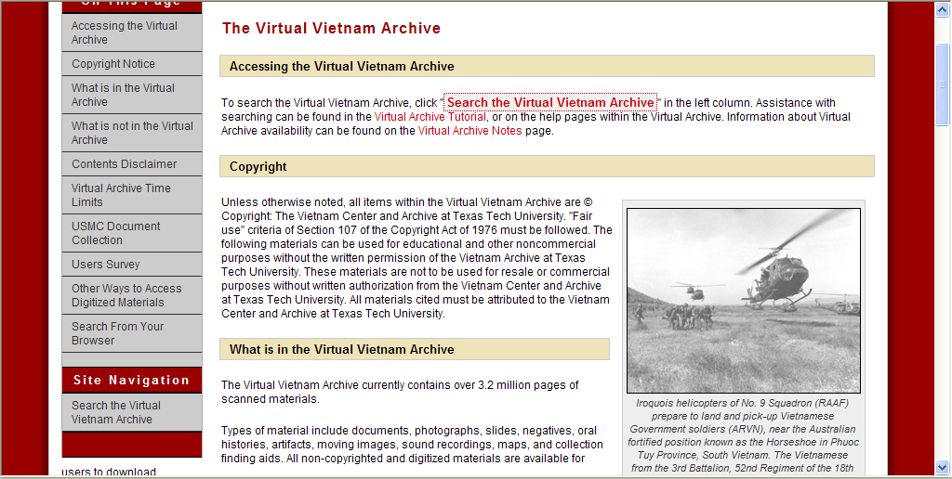

You should see a page similar to the one below; type in A Troop 4/12 Cav and click on the search button

You should see a page similar to the one below

Any one may submit items to the Texas Tech Vietnam Center and Archive Virtual Vietnam Archive.

You may submit items under your name “only” or if you wish have your items associated with A Troop 4/12 Cav.

Information for donating items to the site is located on the Home Page of the site (bottom right hand side).

This site is where the Troop website will end up down the road (not anytime soon). At that point in time the photo site for the Troop may not transfer with the website (at this point in time the photo site is separate and is carried as a link on the Troop website).

